**Learning Outcomes**

1. Understanding Spinner
2. Understanding Seek bar

**Design a layout as shown below**

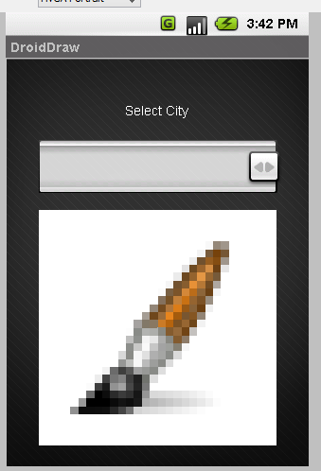**s**

Add a spinner and an Imageview

Under values



Write down the following code

Declare an array as shown in String.xml

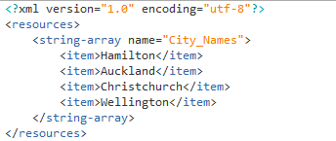

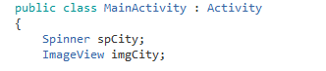

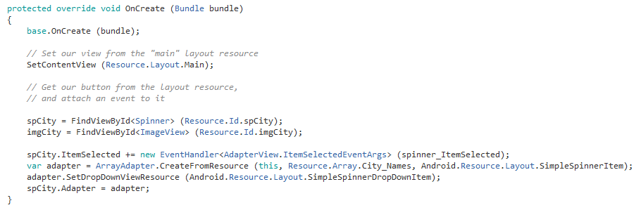

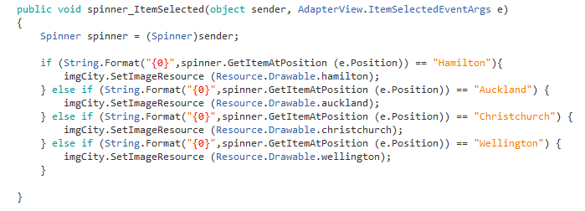

**Design a Currency Converter App**

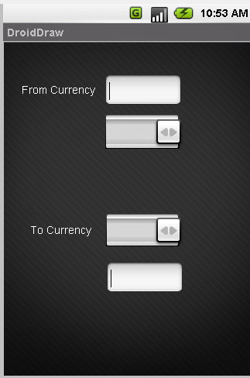

Add the currency in strings.xml

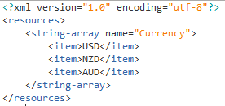

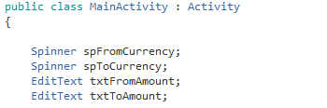

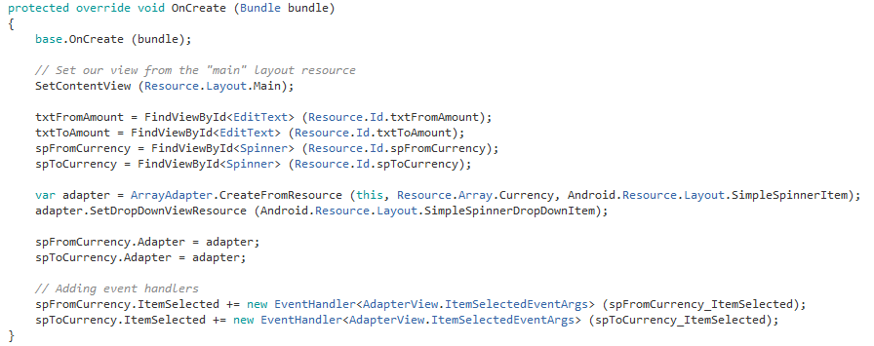

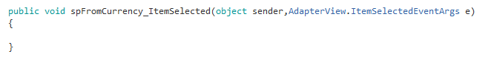

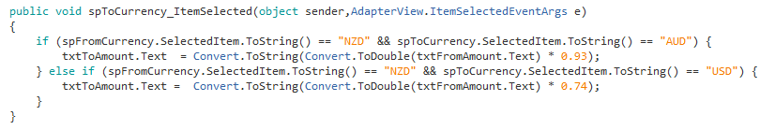

**Seekbar**

SeekBar is another input type control. It takes user’s input to change the SeekBar value. Normally in windows we use Slider control for this.

**Design a layout as shown below**

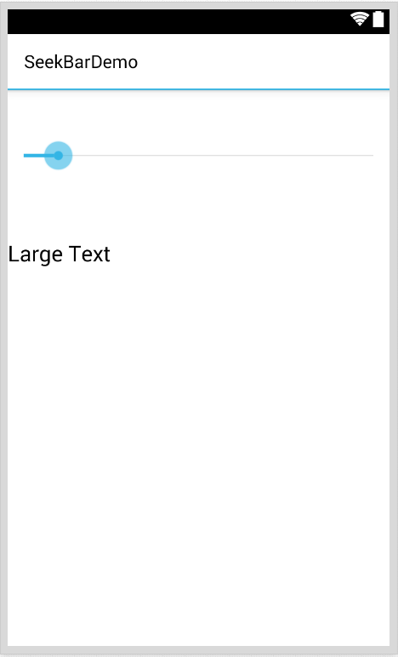

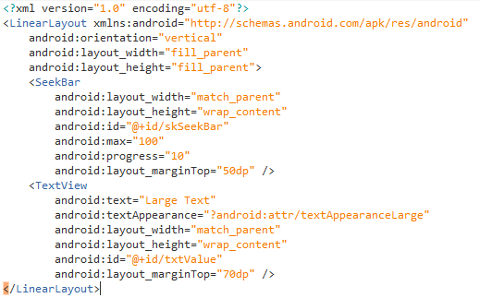

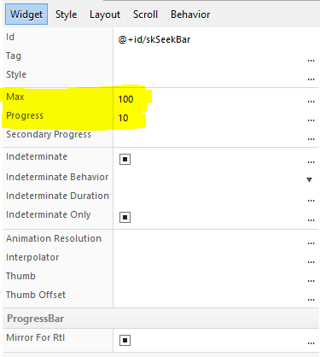

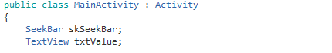

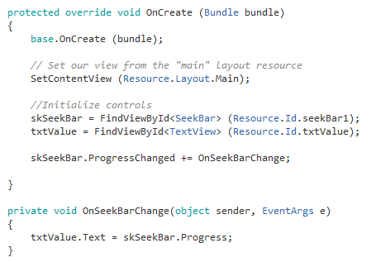

**Exercise**

